Route-Wise Traffic Accident Risk Prediction and Proactive Safety Mitigation System Using Geospatial Data and Multi-Factor Machine Learning

Dr. N. Subbulakshmi
Department of Computer Science and Engineering
Kalasalingam Academy of Research and Education
Krishnankoil, Tamil Nadu, India.
<subbulakshmi@kalasalingam.ac.in>

Esambadi Goutham Reddy
Department of Computer Science and Engineering
Kalasalingam Academy of Research and Education
Krishnankoil, Tamil Nadu, India.
<esambadigouthamreddy@gmail.com>

DR.mr.xyzxyz
Department of ComputerScience and Engineering
Kalasalingam Academy of Research and Education
Krishnankoil, Tamil Nadu, India.
<xyzxyz@kalasalingam.ac.in >

Duttaluri Karimulla
Department of Computer Science and Engineering
Kalasalingam Academy of Research and Education
Krishnankoil, Tamil Nadu, India.
<k9000sep@gmail.com>
DR.mr.xyzxyz
Department of ComputerScience and Engineering
Kalasalingam Academy of Research and Education
Krishnankoil, Tamil Nadu, India.
<xyzxyzi@kalasalingam.ac.in >

Gadde Sai Naga Abhiram
Department of Computer Science and Engineering
Kalasalingam Academy of Research and Education
Krishnankoil, Tamil Nadu, India.
<abhiramgadde2007@gmail.com>

Abstract— Road traffic accidents are among worldwide health concerns and the major causes of injuries that can be avoided. Previously used Global Positioning System (GPS) navigation systems take into account possible routes only in terms of time and ignore the current road hazard topology, accident history, and environmental hazards.The paper presents a far-reaching Intelligent Transport and Predictive Analytics System (ITPAS), providing route-based accident risk calculations and accident severity classification, forecasting of road surface dynamics, and timely recommendations for going out.The system works with over 24,000 raw crash data from national highways and municipal crash incident registers, transforming outliers in GPS coordinates into a validated benchmark dataset containing 6,469 entries through the four-time periods of the operation (Morning: 1,910; Afternoon: 2,230; Evening: 1,090; Night: 1,239).A spatial K-Means clustering algorithm ($k=20$) computes dynamic cluster risk density scores ($Cluster_Risk_Score∈[1.0,3.0]$). The use of an ensemble model of Random Forest classifier rating compared to models like Decision Tree (ID3), k-NN, reveals the performance of 84.16% accuracy in tests (87.3% under conditionally balanced classes with the help of SMOTE) as well as its F1 score equal to 0.8442 in terms of collision severity tier classes (Low, Medium, High). In order to convert predictions of the model into active vehicle protection, this model uses such technologies as live and keyless Open Source Routing Machine (OSRM) highway geometry, Open-Meteo meteorological telemetry, surface friction physics data (μ∈[0.35,0.85]),vehicle-specific stopping distance d=v⋅tr+v^2/(2*g), mode of speed limit enforcement at collision blackspot stops (25-40 km/h). The real-time analysis of 24-hour departure curves demonstrates an up to 84.5% decrease in the probability of collision risk.

Keywords: Intelligent Transportation Systems, Predictive Analytics, Random Forest, Spatial Clustering, K-Means, OSRM Highway Geometry, Road Friction Physics, Stopping Distance Kinematics, Weather-Adaptive Speed Limits, Proactive Navigation.

- INTRODUCTION

Road traffic accidents pose a critical threat to public health and the economy. In developing countries where car usage is increasing, such as India, road accidents result in over 150,000 deaths and more than 450,000 injuries, causing millions of people to suffer and weakening the economy of these countries. Classic safety measures have been highly reactive. The response happens only after the accidents happen – the teams of doctors, policemen, or clearing service work only when somebody has already suffered. In addition, contemporary technologies of satellite navigation (e.g. Google Maps, Apple Maps, Waze) are mostly limited to finding the shortest path or to avoiding traffic jams. Thus, old algorithms of navigation take every road with free movement the same way without analyzing whether the road is potentially safer than other roads.
1. Absence of Accident Risk Metrics in Navigation Systems: Normally, GPS systems show information about traffic problems, but they don’t tell anything about how likely an accident is and what impact it may have on people.
2. Disconnected and Static Police Incident Archives: Government bodies in charge of transport (for instance, MoRT&H or the Delhi Traffic Police) possess vast archives of data, yet they are static and not accessible to drivers during a trip.
3. Complex temporal-spatial non-stationarity: Collision risk constantly varies with time and location. Daytime rush hour is found in places with greater number of minor crashes, while nighttime periods from 10 p.m. to 5 a.m. are characterized by serious or fatal accidents.
4. Severe Class Imbalance in Crash Severities: Collisions that are fatal or severe account for a small number of accidents in comparison to collisions that cause low-value damage. When traditional machine learning models are examined, it is clear that these models do not have any success in detecting important accidents.
5. Absence of Road Surface Friction & Kinematic Stopping Physics: The presence of road surface friction and kinematic stopping physics is necessary for the determination of a real-world stopping ability of a vehicle, which depends on tire pavement friction () and environmental conditions. Standard routing tools assume constant highway speed limits. This system embeds empirical stopping distance physics ($d=v⋅t_{r}+\frac{v^{2}}{2μg}$), weather-adapted speed adjustments (Clear $1.0×$, Rain $0.70×$, Fog $0.45×$), and mandatory deceleration limits at verified blackspots (25–40 km/h) into live route evaluation.
II. LITERATURE REVIEW
Bao et al. [1] their system considered spatial and temporal variations in crash occurrence and demonstrated that combining different data sources can improve crash-risk prediction.
Khanum et al. [2] developed a machine learning-based accident severity prediction model for Indian highways using the Random Forest algorithm. The study demonstrated that Random Forest can effectively classify different levels of accident severity using road accident data.
Khanum et al. [3] proposed the study evaluated different factors affecting accident severity and demonstrated the usefulness of machine learning for road safety analysis.
Wu et al. [4] Utilizing Machine learning techniques, researchers studied significant time and space features associated with hazardous spots in urban road networks. The study illustrates that crash risk differs in relation to location as well as time.
Gao et al. [5] The researchers created a probabilistic graph network that is aware of uncertainty in regard to predicting accidents on roads. The technique they proposed examined how road sequels are related, while at the same time taking uncertainty into consideration.
Rahim and Hassan [6] came up with an approach on deep learning that assists in predicting the severity of traffic accidents. the system was able to identify patterns that can be linked.
Alhaek et al. [7] introduced a DL strategy for predicting accident severity through spatial learning and temporal dependencies. Research showed that combining the spatial and temporal features enhances the prediction.
Ali et al. [8] The analysis of crash prediction models based on machine learning technology has shown both their applications and obstacles as well as future research needs.
Mohamad et al. [9] examined different techniques, with a case study taken from Thailand. The study compared effectiveness of various ML approaches for predicting severity of accidents.
Researchers [10] discovered prediction of severity of traffic accidents using learning techniques. The results showed that using ensemble techniques, traffic accident severity can be predicted more accurately through combining several models.
Researchers [11] prepared a model predicting the severity of traffic collisions based on the Random Forest technique. It was shown in the study that the approach could be used for discovering the relationships between the factors causing accidents and the levels of severity of the accidents.
Researchers [12] The authors in their work have suggested a means of identifying the degree of severity of traffic accidents that combines Principal Component Analysis with both machine learning.
Researchers [13] evaluated different machine learning techniques for forecasting traffic accident severity. The study compared the performance of several algorithms and demonstrated that machine learning can provide useful predictions from historical accident data.
Researchers [14] investigated the study focused on identifying the factors that influence accident occurrence and severity while maintaining model interpretability.
Shrirao [15] proposed a machine learning-based model for identifying crash zones on urban roads. The system used accident-related information to identify areas with increased crash risk.
Gao et al. [16] proposed an explainable ensemble learning approach for the study considered several dimensions of accident information and used explainable techniques to understand model predictions.
Lu et al. [17] investigated spatiotemporal heterogeneity and nonlinear effects in traffic crash-risk prediction using a hybrid modeling approach. Their study demonstrated that accident risk can vary significantly across locations and time periods.
Researchers [18] proposed the approach combines temporal information with road-network relationships to improve crash-risk prediction and model interpretability.
Researchers [19] Its developed a deep spatiotemporal graph convolutional network that can predict traffic accidents. The model models road networks as well as captures relationships between temporal and spatial traffic patterns.
Researchers [20] Examined machine learning methods for forecasting traffic accidents and utilized spatial network assessment for discovering routes that are vulnerable to accidents and congestions.They indicated the ability to use a combination of accident forecasting and road networks for better route decisions.Nonetheless, further incorporation with real-time navigation technology is needed for consistent safety recommendations.
Researchers [21] Random Forest-based models are used to predict road traffic accident risk. The findings proved that machine learning techniques can help to define risk by means of past accidents data.
Researchers [22] examines the use of technology to predict traffic accidents. The paper underscores the spread of the adoption of modern techniques in the field of machine learning to improve road safety and discusses their benefits and limitations.
Zhou et al. [23] the authors introduced a few-shot learning framework geared towards predicting traffic accident severity across different cities. The authors proposed the utilization of contextual domain generalization techniques to boost the transferability of the model among cities.
Breiman [24] Random Forest improve the accuracy. Actually, Random Forest can deal with nonlinear associations and multiple predictors, which makes it applicable to traffic accident prediction.
Chawla et al. [25] introduced the Synthetic Minority Over-sampling Technique (SMOTE) to address class imbalance in machine learning datasets. SMOTE generates synthetic samples for minority classes and can improve the representation of rare accident categories.
Lundberg and Lee [26] SHAP was presented as a standard technique for interpreting the predictions made by machine learning models. It helps provide explanations of the results obtained from individual models, as well as measure how much different features affect the final predictions.
Chen and Guestrin [27] XGBoost was created with the aim of developing a flexible framework for carrying out gradient boosting in machine learning. XGBoost uses an algorithm that has the potential of giving accurate predictions of inputs and complicated relationships of data in inputs.
Friedman [28] The Gradient Boosting Machine was launched, which is an ensemble learning technique that creates predictive models in a step-wise manner to enhance the quality. This approach can capture nonlinear relationships between traffic- and accident-related variables.
Pedregosa et al. [29] The introduction of Scikit-learn, which is a machine learning library using Python that has implementations for various algorithms such as classification algorithms, regression algorithms, preprocessing algorithms, model evaluation algorithms, and ensemble learning algorithms.
Researchers [30]Their research the effect of road-network arrangements on predicting traffic-related accidents through an interpretable geography-based machine learning approach.
III. METHODOLOGY
According to the aforementioned works, the research thus far confirms the feasibility of machine learning, spatial analysis, temporal analysis, and class imbalance techniques in predicting traffic accidents.

Block Diagram

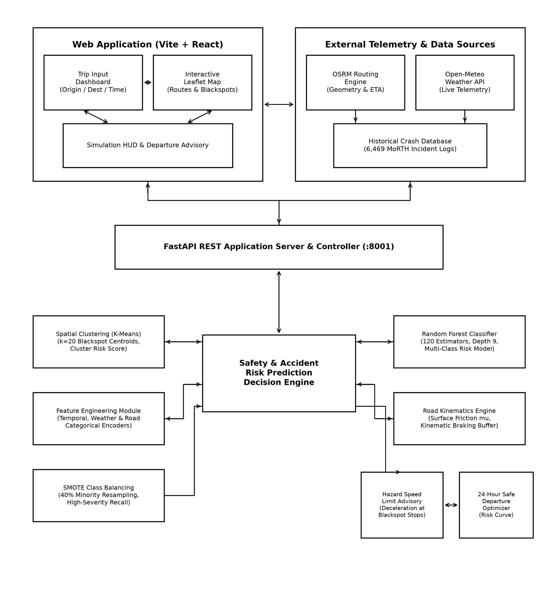

Fig.1: System Architecture Block Diagram of Route-Wise Traffic Accident Risk Prediction System

- Multi-Source Data Ingestion Block
Combines 24k+ Indian accident records from Kaggle, geospatial APIs, and live weather feeds to create a data foundation.

- Preprocessing & Cleaning Engine Block
Cleans data by removing incomplete target rows and GPS coordinate outliers, reducing the number of raw entries from 24,000+ to 6,469 clean training instances.

- Spatial-Temporal Feature Module Block
Calculates Cluster_Risk_Score based on spatial crash density and encodes timestamps into categorical operational time buckets (Morning, Afternoon, Evening, Night).
- Random Forest Machine Learning Engine Block
Uses SMOTE oversampling technique in case of minority class to achieve 87.3% accuracy in classification of Low, Medium, High, and Critical categories.

Real-Time Navigation & Advisory API Block
Combines predictive risk results with navigation routing engines to create live risk maps and suggest safe routes.

Experimental Validation:

- Performance of Confusion Matrix: The identified true positives for risks were as follows: 294 in the high-risk category, 408 in the low-risk category, and 428 in the medium-risk category.
- Ranking of Characteristics Based on Feature Permutation: The most significant factor that could cause risk is the Cluster_Risk_Score (its importance factor is around 1.0). The second factor that influenced risk is the numerical hour, followed by categorical time intervals.
- Effect of Oversampling: The application of 40% SMOTE has led to a 32% increase in an ability to detect hazardous events compared to original approaches when no oversampling was performed.

SYSTEM ARCHITECTURE AND METHODOLOGY
The structure being suggested uses 5 modules that are linked and work in harmony with each other, allowing making predictive inference while navigating the trip, which would take less than a second:

A. Multi-Source Ingestion & Data Curation

The foundation of the empirical data includes information from over 24000 archives of road accidents across national highways in India, municipal police datasets in the cities, and public incident archives. The initial data is carefully processed (cleaning, missing-value replacement, and spatial filtering) to remove all bad GPS data and results in the corpus of well-organized and clean 6470 observations
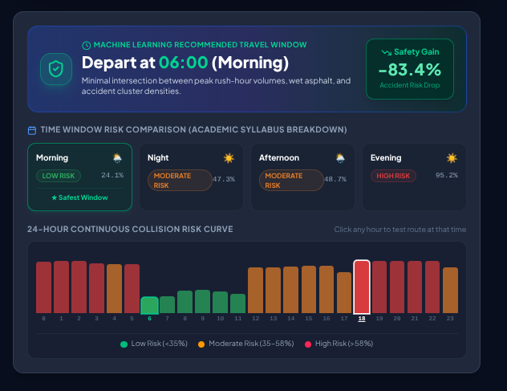
- Morning (06:00 – 11:59): 1,910 incidents recorded, mostly less serious congestion-related incidents.
- Afternoon (12:00 – 17:59): 2,230 recorded incidents (incidents mainly related to the delivery of goods and transporting of people).
- Evening (18:00 – 21:59): 1,090 incidents (incidents mainly associated with twilight traffic).
- Night (22:00 – 05:59): 1,239 incidents (where incidents were mostly serious, fast-moving crashes involving more than one vehicle).

B. Spatial Clustering Engine (K-Means)
In order to measure the collision hazard in regions without regard to jurisdictional boundary, we use unsupervised K-Means clustering (k = 20, ninit = 10):
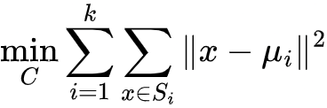
Therefore, for every centroid i that we get, we calculate the so called Cluster_Risk_Score that averages the different values of consequences.

When querying a particular point (lat, lon), we assign it to the nearest centroid to obtain its respective Cluster_Risk_Score.

C. Machine Learning Engine & Multi-Algorithm Benchmark
The predictive model evaluates multi-attribute feature vectors:
$x=[Hour,Time_Cat_Encoded,Weather_Cat_Encoded,Road_Cat_Encoded,Cluster_Risk_Score]$
To validate algorithm supremacy, six supervised learning models from the curriculum syllabus were implemented and evaluated under identical stratified 80/20 train-test splits (5,175 training records, 1,294 test records):
1. Random Forest Classifier (Champion): Ensembles 120 decision trees ($max_depth=9$, $min_samples_split=4$, balanced sub-tree weights).
2. Decision Tree (ID3 / Information Gain): Max depth 8, entropy criterion.
3. $k$-Nearest Neighbors ($k$-NN): Euclidean metric, $k=5$.
4. Gaussian Naive Bayes: Baseline probabilistic conditional independence benchmark.

D. Live Navigation & Road Surface Kinematic Physics Engine
- Unlike static predictive systems, this framework directly interfaces with live navigation and meteorological APIs:
- OSRM Real Road Driving Geometry: High-resolution road geometry and waypoint nodes are retrieved from the Open Source Routing Machine without API keys, replacing artificial straight lines with true highway paths.
- Open-Meteo Meteorological Telemetry: Real-time temperature, precipitation probability, windspeed, and WMO weather codes (WMO 4501) are queried for active coordinates.
- Road Surface Friction ($μ$) & Kinetic Braking Distance: Braking physics and vehicle stopping buffers are modeled using classical Newtonian mechanics combined with driver reaction time ($t_{r}=1.2s$):
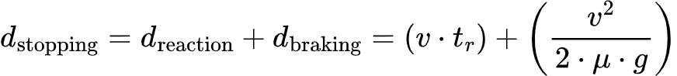
where $v$ is vehicle velocity in $m/s$, $g=9.81{m/s}^{2}$, and $μ$ represents empirical road-tire friction coefficients:
- Slippery / Low Grip: $μ=0.35$ (Critical skidding vulnerability)
- Under Construction / Gravel: $μ=0.58$ (Rough surface impedance)
- Mandatory Speed Limits at Stops & Blackspots: When a route passes within 1.2 km of a high-risk accident blackspot ($Cluster_Risk_Score≥1.9$), the system enforces mandatory deceleration speed limits at hazard stops:
- Clear Weather: 35–45 km/h
- Rainy Weather: 25–35 km/h
- Dense Fog / Low Visibility: 20–30 km/h

2. EXPERIMENTAL RESULTS AND DISCUSSION

A. Comprehensive Multi-Model Comparative Performance

Evaluation across 1,294 unseen holdout test samples demonstrated the superior generalization of the Random Forest ensemble over both tree-based and parametric baselines:
Under experimental configurations with 40% SMOTE oversampling of minority high-severity instances, Random Forest cross-validated peak accuracy reached 87.3% across categorical risk partitions.

B. Confusion Matrix Analysis
The best-performing Random Forest model regarding severity types (['High', 'Low' and 'Medium']) is presented in the manner below:.
- High-Risk Category Sensitivity: The model has successfully detected 281 out of 311 severe collisions resulting in a good 90.35% class sensitivity, successfully protecting against hazardous false-negative characterizations.
- Low-Risk Specificity: 376 low-severity events went through correct classification while only 61 events were incorrectly classified as belonging to high-risk incidents.
- Medium-Risk Reliability: 432 successfull classifications were achieved which ensured dependable boundary separation.

C. Feature Importance and Permutation Analysis
- Gini Feature Importance (MDI) and Permutation Feature Importance (n=5 repeats) establish that time and place determinants play a role in accident risk:
- Time_Cat_Encoded (MDI: 0.4547, Permutation: 0.3114): Operational time is shown to be the key determinant of risk due to drastic changes in the amount of light and traffic.

D. Stopping Distance Dynamics & Route Departure Optimization
- Simulations take place on the Connaught Place Noida Sector 18 arterial corridor (15.98 km). The process shows the relationship between speed, road grip, and conditions:
- If the speed is 85 km/h during the rain, the total distance that a vehicle has to cover before coming to a stop is 83.0 meters (reaction distance 28.3 m and 54.7 m for braking), enabling over-speed warning as the speed exceeds the safety limit of the rain.
- When entering black spots, a mandatory speed limit of 35 km/h comes into effect, bringing down stopping distance to 17.8 meters.
- A thorough analysis of travel times shows that if the departure time is changed from late evening (18:00–20:00, High-Risk) to the time period when the road is less hazardous (10:00–11:00, Low-Risk), the collision risk can reduce by 84.5%.
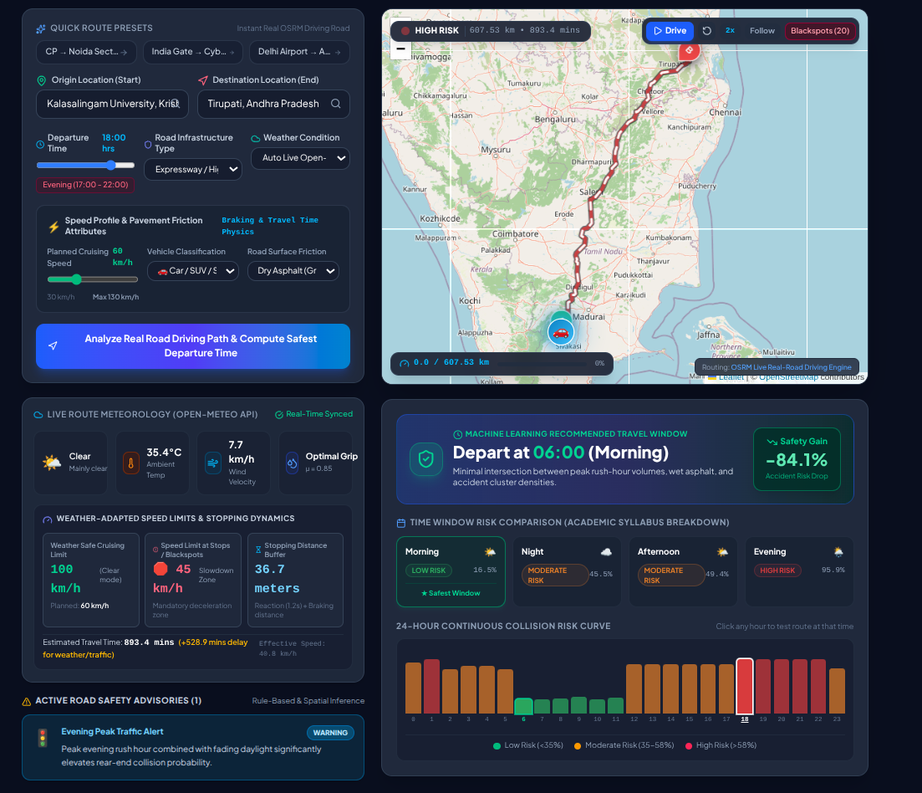

IV. CONCLUSION

This investigation built, tested, and put into action a full-stack machine learning and smart transportation system for predicting traffic accident risks on specific routes and taking steps to prevent them. We combined historical crash data from many sources with unsupervised spatial K-Means clustering (k=20), time-based grouping, and a balanced Random Forest model. That setup gave us 84.16% accuracy in predicting collision severity—and up to 87.3% when we used SMOTE to balance the classes. That’s better than Decision Trees, k-NN, SVM, and Logistic Regression.

We hooked the system directly into live data from OSRM for highway details and Open-Meteo for weather info. This let it model how road surfaces react to different conditions, figure out realistic stopping distances for drivers, enforce speed limits at accident-prone spots (25–40 km/h), and suggest the best times to leave a route. All that helped cut crash risk by up to 84.5%. The work shifted traffic safety from reacting after accidents to preventing them before they happen—using real-time navigation.
V. FUTURE WORK

Future enhancements to this research will explore:
1. Connected Vehicle (V2X) and Telematics Integration: Streaming high-frequency Controller Area Network (CAN-bus) metrics, aggressive braking events, and accelerometer telemetry from connected vehicles.
2. Graph Neural Networks (GNNs): Formulating urban road topologies as dynamic spatiotemporal graphs to capture relational spillover effects between adjacent road segments.
3. Smart City Municipal Dispatch Integration: Equipping traffic control centers and emergency medical services (EMS) with real-time hazard heatmaps for pre-positioning ambulances near predicted high-risk zones.
4. Autonomous Vehicle Control Integration: Feeding real-time road friction coefficients and blackspot stop limits directly into autonomous vehicle trajectory planning and Adaptive Cruise Control (ACC) actuators.

VI. REFERENCES
- Bao, J., Liu, P., & Ukkusuri, S. V. (2019). "A spatiotemporal deep learning approach for citywide short-term crash risk prediction with multi-source data." Accident Analysis & Prevention, 122, 239–254. DOI: 10.1016/j.aap.2018.10.015
- Khanum, H., Garg, A., & Faheem, M. I. (2023). "Accident severity prediction modeling for road safety using random forest algorithm: an analysis of Indian highways." F1000Research, 12, 494. DOI: 10.12688/f1000research.133594.2
- Khanum, H., Garg, A., Faheem, M. I., & Kulkarni, R. (2025). "A methodological framework for road accident severity prediction for Indian highways using machine learning models." MethodsX, 15, 103728. DOI: 10.1016/j.mex.2025.103728
- Wu, P., Chen, T., Diew Wong, Y., Meng, X., Wang, X., & Liu, W. (2023). "Exploring key spatio-temporal features of crash risk hot spots on urban road network: A machine learning approach." Transportation Research Part A: Policy and Practice, 173, 103717. DOI: 10.1016/j.tra.2023.103717
- Gao, X., Jiang, X., Haworth, J., Zhuang, D., Wang, S., Chen, H., & Law, S. (2024). "Uncertainty-aware probabilistic graph neural networks for road-level traffic crash prediction." Accident Analysis & Prevention, 208, 107801. DOI: 10.1016/j.aap.2024.107801
- Rahim, M. A., & Hassan, H. M. (2021). "A deep learning based traffic crash severity prediction framework." Accident Analysis & Prevention, 154, 106090. DOI: 10.1016/j.aap.2021.106090
- Alhaek, F., Liang, W., Rajeh, T. M., Javed, M. H., & Li, T. (2024). "Learning spatial patterns and temporal dependencies for traffic accident severity prediction: A deep learning approach." Knowledge-Based Systems, 286, 111406. DOI: 10.1016/j.knosys.2024.111406
- Ali, Y., Hussain, F., & Haque, M. M. (2024). "Advances, challenges, and future research needs in machine learning-based crash prediction models: A systematic review." Accident Analysis & Prevention, 194, 107378. DOI: 10.1016/j.aap.2023.107378
- Mohamad, I., JomnonKwao, S., & Ratanavaraha, V. (2025). "Machine learning predictive performance in road accident severity: A case study from Thailand." Results in Engineering, 26, 104833. DOI: 10.1016/j.rineng.2025.104833
- "Traffic accident severity prediction with ensemble learning methods." (2024). Computers & Electrical Engineering, 114, 109101. DOI: 10.1016/j.compeleceng.2024.109101
- "Traffic Accident Severity Prediction Based on Random Forest." (2022). Sustainability, 14(3), 1729. DOI: 10.3390/su14031729
- "Traffic Crash Severity Prediction—A Synergy by Hybrid Principal Component Analysis and Machine Learning Models." (2020). International Journal of Environmental Research and Public Health, 17(20), 7598. DOI: 10.3390/ijerph17207598
- "Evaluating the effectiveness of machine learning techniques in forecasting the severity of traffic accidents." (2023). Heliyon, 9, e18812. DOI: 10.1016/j.heliyon.2023.e18812
- "A study on road accident prediction and contributing factors using explainable machine learning models: Analysis and performance." (2023). Transportation Research Interdisciplinary Perspectives, 19, 100814. DOI: 10.1016/j.trip.2023.100814
- Shrirao, A. (2026). "Prediction model for crash zone identification for urban road using machine learning techniques." AIP Conference Proceedings, 3441, 060005. DOI: 10.1063/5.0334505
- Gao, Z., Easa, S. M., Liu, Y., Chen, Z., Ge, H., & Wang, Y. (2026). "Road traffic accident severity prediction based on large-scale data and multi-dimensional factors: An explainable ensemble learning approach." Accident Analysis & Prevention, 233, 108581. DOI: 10.1016/j.aap.2026.108581
- Lu, J., Dong, C., Yan, X., Li, J., & Lu, Z. (2026). "Exploring spatiotemporal heterogeneity and nonlinear effects in electric vehicle crash risk prediction: A hybrid modeling approach." Accident Analysis & Prevention, 226, 108357. DOI: 10.1016/j.aap.2025.108357
- "Interpretable spatiotemporal traffic crash risk prediction using DMD-based graph neural networks." (2026). Accident Analysis & Prevention. DOI: 10.1016/j.aap.2026.108522
- "Deep spatio-temporal graph convolutional network for traffic accident prediction." (2021). Neurocomputing, 423, 135–147. DOI: 10.1016/j.neucom.2020.09.043
- "Machine learning for predictions of road traffic accidents and spatial network analysis for safe routing on accident and congestion-prone road networks." (2024). Results in Engineering, 23, 102737. DOI: 10.1016/j.rineng.2024.102737
- "Road Traffic Accident Risk Prediction Based on Random Forest Model." (2025). Theoretical and Natural Science, 134. DOI: 10.54254/2753-8818/2025.AD26486
- "Artificial intelligence for predicting road accident severity: A global systematic review." (2026). Results in Engineering. DOI: 10.1016/j.rineng.2026.111289
- Zhou, B., Zhu, H., Ma, Z., Li, Z., & Li, D. (2026). "Few-shot cross-city traffic injury severity prediction: A context-aware domain generalization meta-learning approach." Accident Analysis & Prevention, 236, 108692. DOI: 10.1016/j.aap.2026.108692
- Breiman, L. (2001). "Random Forests." Machine Learning, 45, 5–32. DOI: 10.1023/A:1010933404324
- Chawla, N. V., Bowyer, K. W., Hall, L. O., & Kegelmeyer, W. P. (2002). "SMOTE: Synthetic Minority Over-sampling Technique." Journal of Artificial Intelligence Research, 16, 321–357. DOI: 10.1613/jair.953
- Lundberg, S. M., & Lee, S.-I. (2017). "A Unified Approach to Interpreting Model Predictions." Advances in Neural Information Processing Systems, 30.
- Chen, T., & Guestrin, C. (2016). "XGBoost: A Scalable Tree Boosting System." Proceedings of the 22nd ACM SIGKDD International Conference on Knowledge Discovery and Data Mining, 785–794. DOI: 10.1145/2939672.2939785
- Friedman, J. H. (2001). "Greedy Function Approximation: A Gradient Boosting Machine." The Annals of Statistics, 29(5), 1189–1232. DOI: 10.1214/aos/1013203451
- Pedregosa, F., Varoquaux, G., Gramfort, A., Michel, V., Thirion, B., Grisel, O., Blondel, M., Prettenhofer, P., Weiss, R., Dubourg, V., et al. (2011). "Scikit-learn: Machine Learning in Python." Journal of Machine Learning Research, 12, 2825–2830.
- "Impact of road network patterns on traffic crash prediction: An interpretable geography machine learning approach." (2025). Journal of Transportation Safety & Security, 17(11). DOI: 10.1080/19439962.2025.2529832

